

UNIVERSITY OF THE EAST

Caloocan City, Philippines

The University of the East College of Engineering-Caloocan will offer limited face-to-face classes for laboratory classes identified by CHED for the students to fully attain and realize the competencies and skills that are compliant to the academic requirements for graduation and licensure examinations. Protective measures to reduce the spread of COVID-19 are put in place within the system.

--------------------------------------------------------------------------------------------------------------------------

I, ISHMAEL L. RAMIREZ, of legal age, Filipino, and a resident of Unit 338 Tower 3 SMDC Trees Residences Quirino Highway, Barangay Pasong Putik, Fairview Quezon City, do hereby depose and state that:

1. I am willing to undergo limited face-to-face classes (CIT3101 – Networking 2) under the College of Engineering as scheduled from August 8, 2022 to December 17, 2022 in compliance with the new CHED Memorandum Order 19 s. 2021 and CHED-DOH Joint Memorandum Circular 004 s. 2021.

2. I understand that I may undergo online classes, aside from face-to-face activities;

3. I understand that given the current pandemic, there is a risk that I may contract SARS-COV- 2 during the face-to-face class schedule;

4. I understand that only fully vaccinated students are allowed to attend face to face classes.

5. I understand that personal protective equipment such as face masks and face shields are required upon entry to the UE Caloocan building and to be worn during the duration of stay inside its premises, and will not be provided by UE as these are mandatory for each ordinary individual in the community;

6. I understand that I am expected to abide by the institutional policies and follow all the infection prevention and control protocols established by UE-College of Engineering;

8. I understand that am expected to practice and follow the recommended quarantine procedures at home, and that during the face-to-face activities, I am to refrain from going to any gathering or shopping area with potential exposures to SARS-COV-2 or other virus;

9. I hereby hold the University of the East free and harmless from any claim, obligation or liability for accidents, injury, death or other similar occurrences that may befall to me during the limited face-to-face laboratory arising from my infection with the SARS-COV-2 or other virus, or for causes not attributable to the fault or negligence of the University of the East or its officers, faculty, or employees.

10. I have read this document and understood its contents clearly and this undertaking is hereby given willingly and voluntarily with full knowledge of my rights under the law;

11. I shall keep in confidence and not disclose, except only when authorized by law, the execution and contents of this document; and

12. I am executing this informed consent to attest to the truthfulness of the foregoing facts and for all legal intents and purposes it may serve.

Signed this 10th of August 2022, Manila.

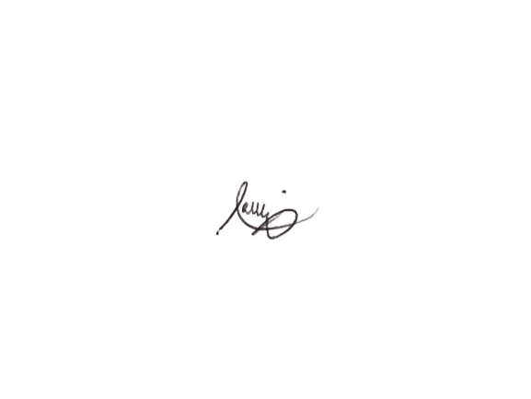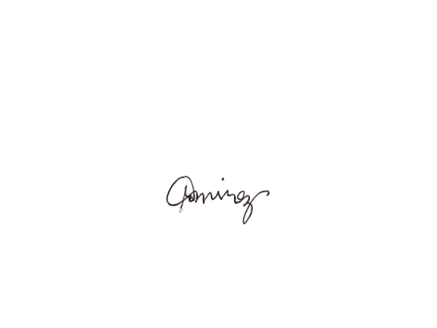

ISHMAEL L. RAMIREZ ROSALIA L. RAMIREZ

**Signature over Printed Name of STUDENT Signature over Printed Name of PARENT**